Home learning activities
Bore da, I am looking forward to our ‘catch up’ sessions soon! Remember there are eBooks to accompany your activities and more resources available on the school website. Have fun! Stay safe! Lots of hugs Mrs Simons 😊
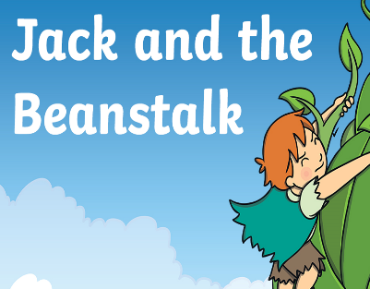  Read a traditional tale | Retell a story  Retell the story of Jack and the bean stalk in the correct order. Create your own story map to help you. You could create a set of puppets or drawing to help you retell the story. | Practise writing sentences  Make a set of cards using anything you have around the house- paper, card, carboard and posits. Select a card to make you own sentence. Write the sentence correctly. Remember to write cursively. | Learn how things grow.  Learn about plants and how they grow. Plant seeds, flowers or fruit in the garden. Watch the plant grow.  Can you say what plants need?  Can you create a flowchart to show what happens to a plant?  Can you record the growth and measure the height of your plant each week? | Memorise and perform song.  Beanstalk growing tall, Beanstalk growing tall. Swishy, swashy, swishy, swashy, Beanstalk growing tall.  Reaching to the clouds, Reaching to the clouds. Growing taller, growing taller, Reaching to the clouds.
Practise estimating and checking.  Select a group of objects from around the house and practise estimating and counting them. Make sensible estimations and check my answers. | Use HWB to create online  Practice logging into Hwb and using the Just2easy resources. Create a Jack and the Beanstalk eBook story using the paint and write feature on HWB JIT5. | Experiment with materials  Create a piece of artwork to represent the story of ‘Jack and the beanstalk. You could use paints, pencils, felts or recyclable materials. | Keep fit and healthy.  Raise your heart level and improve your stamina with shuttle runs. Place 4 objects from around the house in a line. Run to each object.  Can you time yourself? Can you record your times in a table? Can you beat your time? | Solve maths problems.  Can you solve add and subtraction problems to 10 or 20?You can use items around the house to help you add and subtract. Can you make your own problems?  You can use toys and items around the house to help you!
Play together as a family.  Design a board game for Jack to play with his mum. Can you write a set of instructions to play the game? Can you explain how to play the game? | Be thankful  Write a prayer to show that we are thankful for the world that we live in. | Learn to read and then spell  Practise reading and spelling these high frequency words:  he she  we me  be was  you they  all are  my her | Learn to tell the time.  Watch YouTube videos about the time- o’clock and half past.  Make your own clock using card or cardboard and practise telling and reading the time. | Be positive about yourself.  Write down five kind comments about yourself, things your grateful for or things that make you happy.k about
Go outdoors  Go on a walk and collect lots of sticks and leaves. Create a beanstalk. | Play a welsh game  https://cyw.cymru/en/games/ | Read, read and read more!  Continue to read at home. Practise answering questions about the text:  Who? What? When? Why? Where? | Practise your fine motor skills  Make a finger gym. Thread cereal hoops onto spaghetti pasta. How many can you thread in 30 seconds? | Practise asking welsh questions.  Beth wyt ti’n wisgo?  What are you wearing?  Dw i’n gwisgo  I am wearing…
Here is a list of phonics and maths skills that you could practise at home. Use your practical ideas booklet from pack 1 with these.
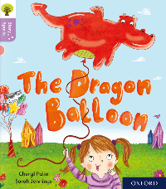  Glas/Melyn | 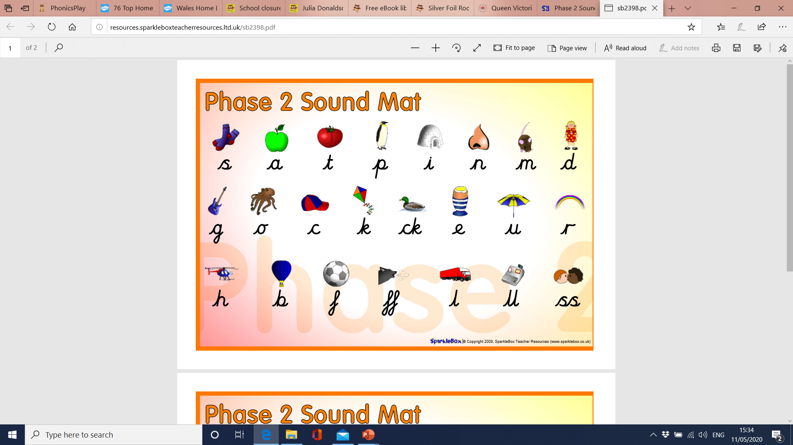 | Practise reading and spelling your tricky words each day.  the  to  I  no  go  into | Read two pages of a book daily. eBooks are available on the school website and Oxford Owls.  Read the blurb and front cover together.  Sound out unfamiliar words together.  Talk about the pictures. What is happening?  Use the pictures to retell the story in your own words. What happened in the beginning, middle and end? | We are learning to add and takeaway numbers to 10.  We are learning to recognise simple 2D shapes.  We are learning to measure by looking for the smallest and largest, heaviest and lightest, most and least.
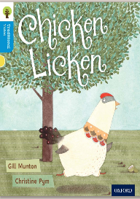  Melyn/Porffor | 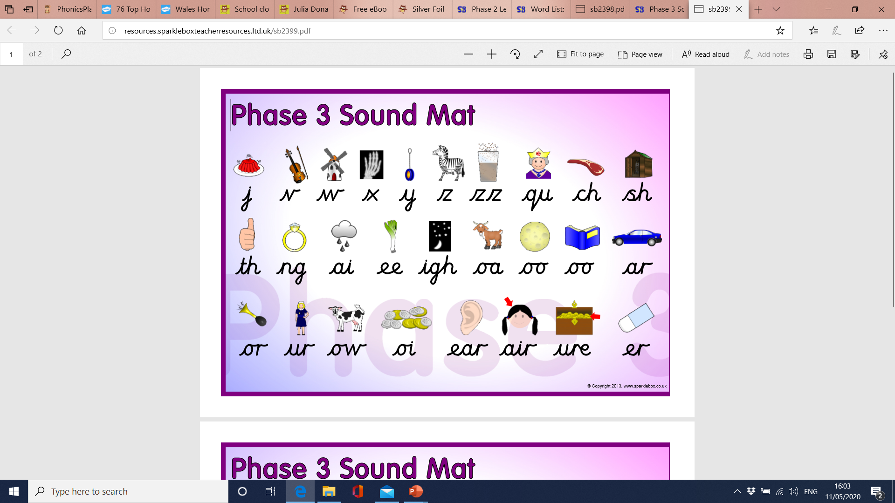 | Practise reading and spelling your tricky words each day.  he she  we me  be was  you they  all are  my her | Read daily. You could read newspapers, magazines, books, eBooks, posters and signs. eBooks are available on the school website and Oxford Owls.  Begin to practise reading with expression. Use the punctuation to pause.  Read the high frequency words without sounding them out. | We are learning to solve problems that add or subtract within 10.  We are learning to estimate and check items to 20.  We are learning to read the time to the nearest hour… o’clock.
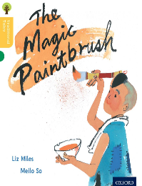  Porffor | 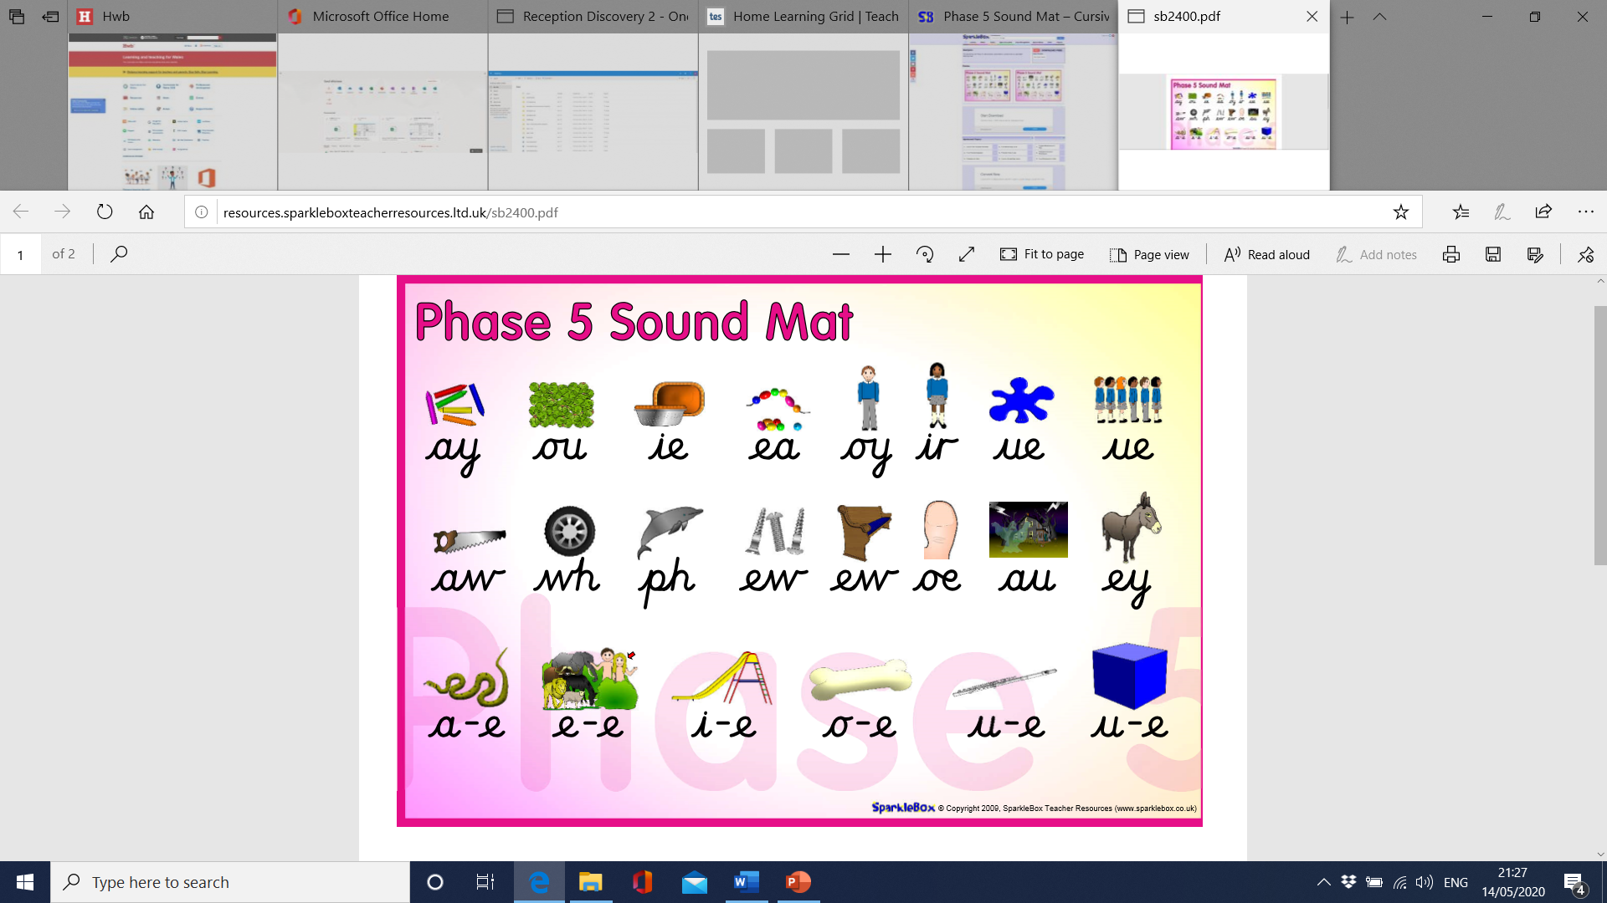 | Practise reading and spelling your tricky words each day.  said have like so do some come were there little one when out what oh their  people Mr Mrs looked called asked could | Read daily. You could read magazines, books, eBooks, posters and signs. eBooks are available on the school website and Oxford Owls.  Begin to practise reading with expression. Use the punctuation to pause.  Read the high frequency words without sounding them out. | We are learning to solve problems that add and takeaway numbers to 20 .  We are learning to estimate and check larger number of items.  We are learning to read the time to the nearest half an hour… o’clock and half past.

